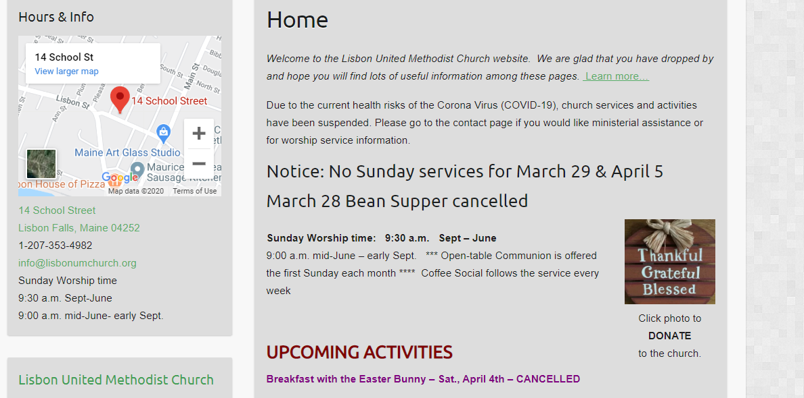
On the LUMC Home page: Click on the designated photo “button”. It will bring you to the donation page where donations can be made as a “guest” or with a named personal profile (preferred for church members/regular donors). (There is no actual page on the web site - it is hosted by Vanco Give+.)

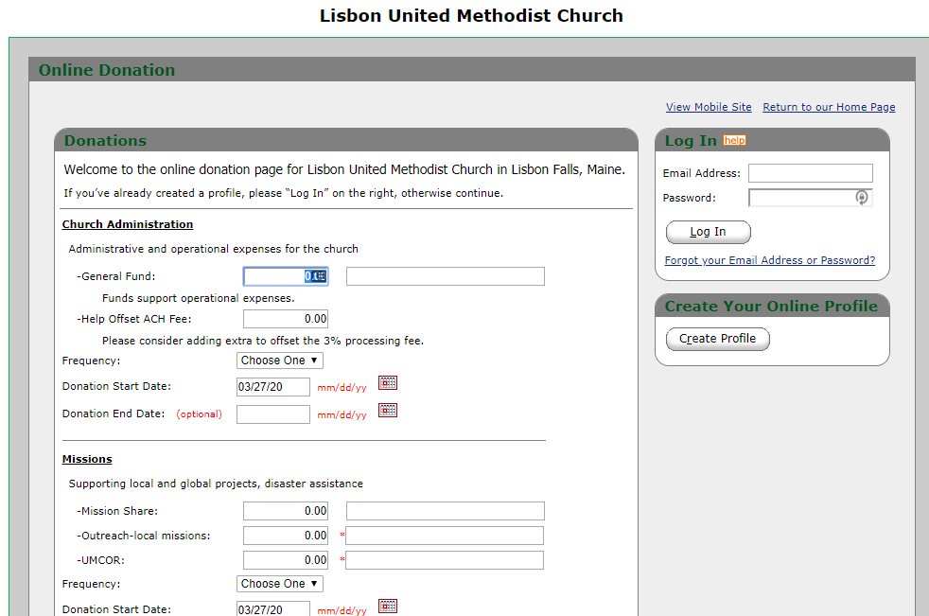
Clicking on the “Create Profile” button will bring you to this page. Follow the prompts to complete the personal profile, including banking information for credit card and/or checking accounts. Once you have completed the forms you will be directed to the donation page. You will also be able to access the form using a mobile phone or other device.

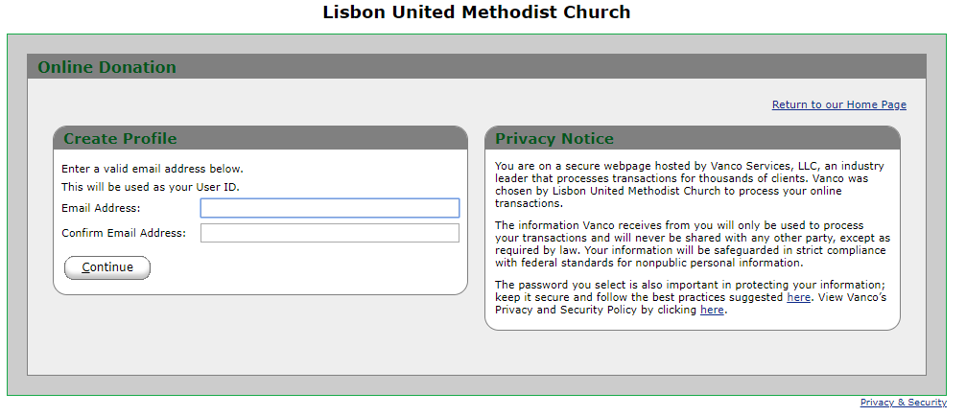
When returning to make additional donations: log in with your credentials. You will be presented with a page showing your transaction history. To make the next donation, click “Add Transaction” button.

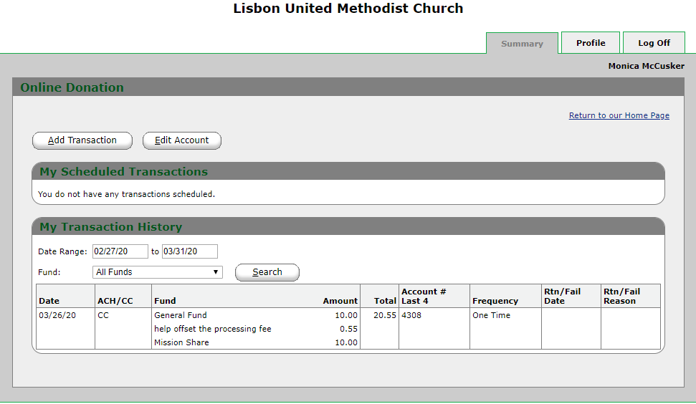
“Add Transaction” button will bring you to the donation page:
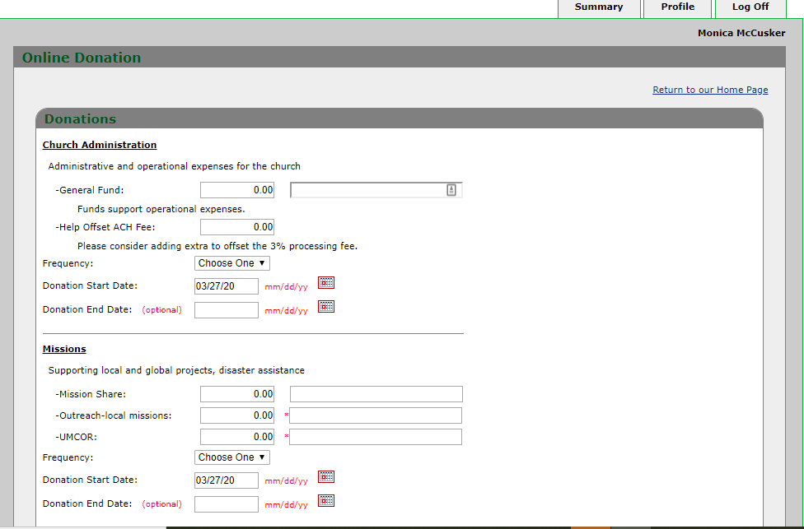
When you have filled in the donation page and clicked “Continue” you will be able to select the type of payment for that specific donation. You can also modify the frequency of payment and edit the donation amounts at this time. Once completed, click the “robot” button and “Process”.

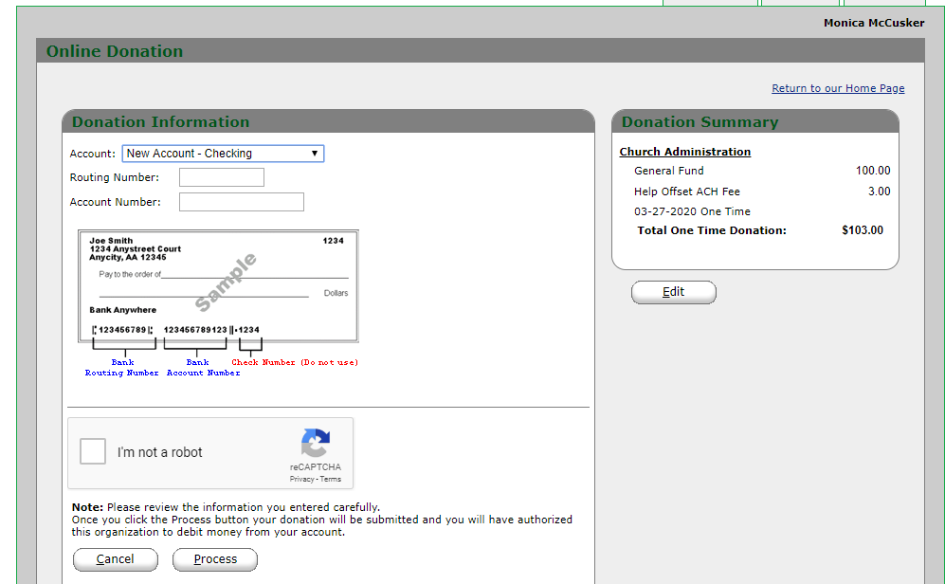
ACH payments from checking/savings accounts must be dated for next business day. If you receive a message indicating the earliest date to use, simply change the date and click “Continue.”

At the conclusion of the transaction, you will receive a “Thank You” page and a receipt will be emailed to the address provided in your profile.

A VIRTUAL TERMINAL feature is also available for us. A special swipe reader was ordered for special activities such as fundraisers and other activities. (Training on that is pending.)

